**Problem 1:**

**Question 1:**

Autonomous vehicles developed by different companies and their respective autonomous driving functions:

* **Audi A8:** [1]

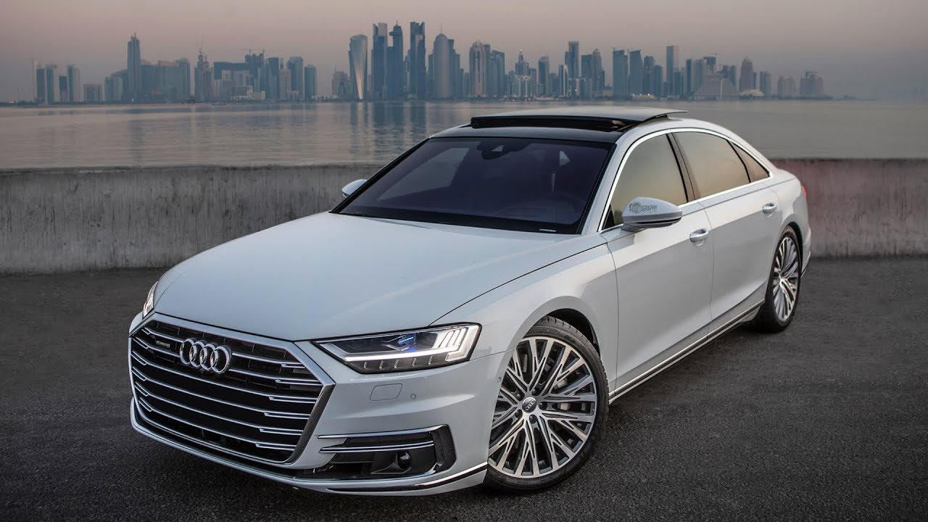

Figure 1 Audi A8

Autonomous driving functions include:

* + Lane Keep Assist.
  + Automatic parking.
  + Adaptive cruise control with accelerate, resume, and coast features.
  + Traffic jam pilot.
  + Connected services.
  + Automatic windshield wipers and headlights.
  + Advanced key technology for keyless start, stop, and entry with hands-free trunk release.

SAE level: Level 3

Reason: Audi defines their A8 model as "conditional autonomy," where the vehicle can drive from a starting point to reach the destination without human involvement, but only in certain driving conditions. If the system is unable to drive safely or reliably, then human involvement is necessary. This typically means that the driver needs to be cautious and be ready in all circumstances.

* **Cadillac Super Cruise CT6:** [2]

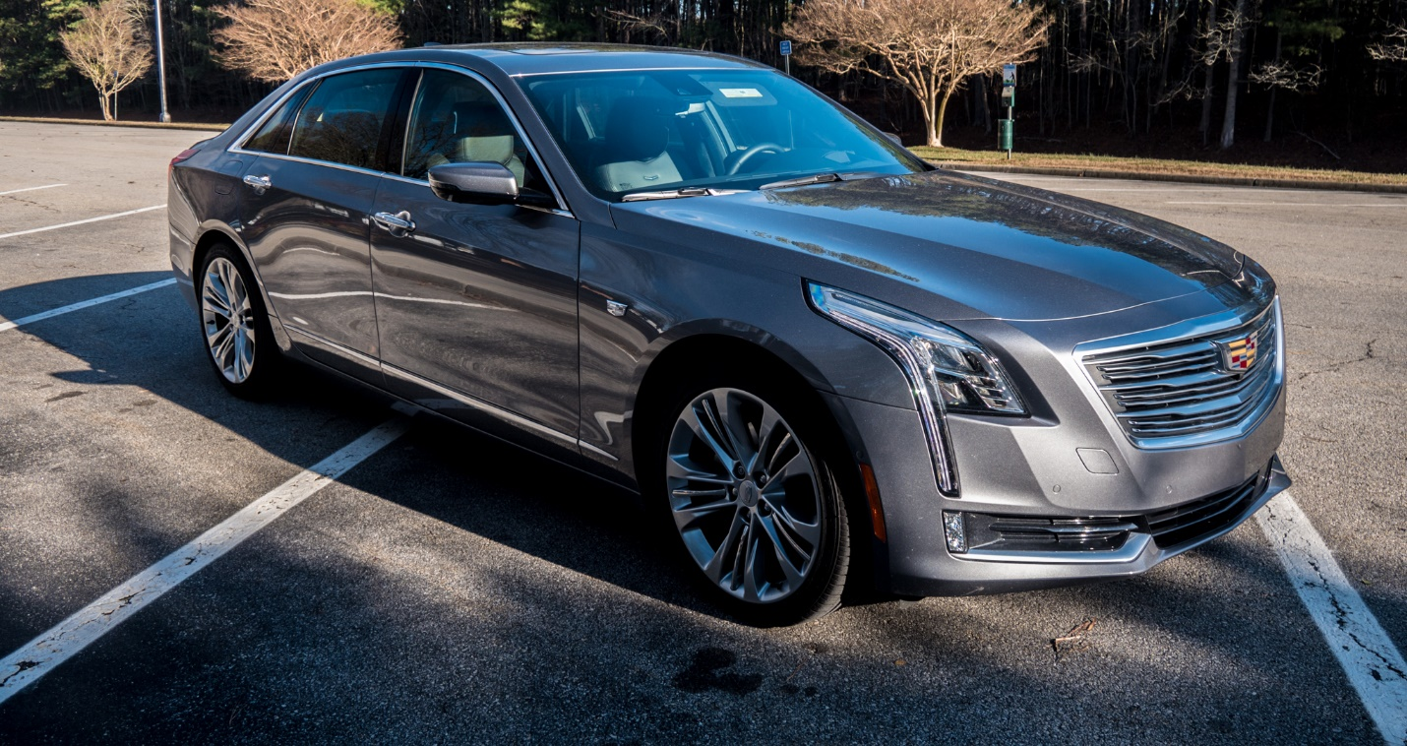

Figure 2 Cadillac Super Cruise CT6

Autonomous driving functions include:

* Active Lane Keep Assist.
* Adaptive cruise control.
* Connected services.
* Real-time precise positioning using perceptive sensors.
* Auto Park Assist
* Intelligent braking.

SAE level: Level 2

Reason: The vehicle possesses basic Advanced Driver Assistance System (ADAS) features, which can help in hands-free driving with human intervention when needed. The driver has a responsibility to pay attention and be ready to take over the vehicle at any time, depending upon the situation.

* **Waymo cars:** [3]

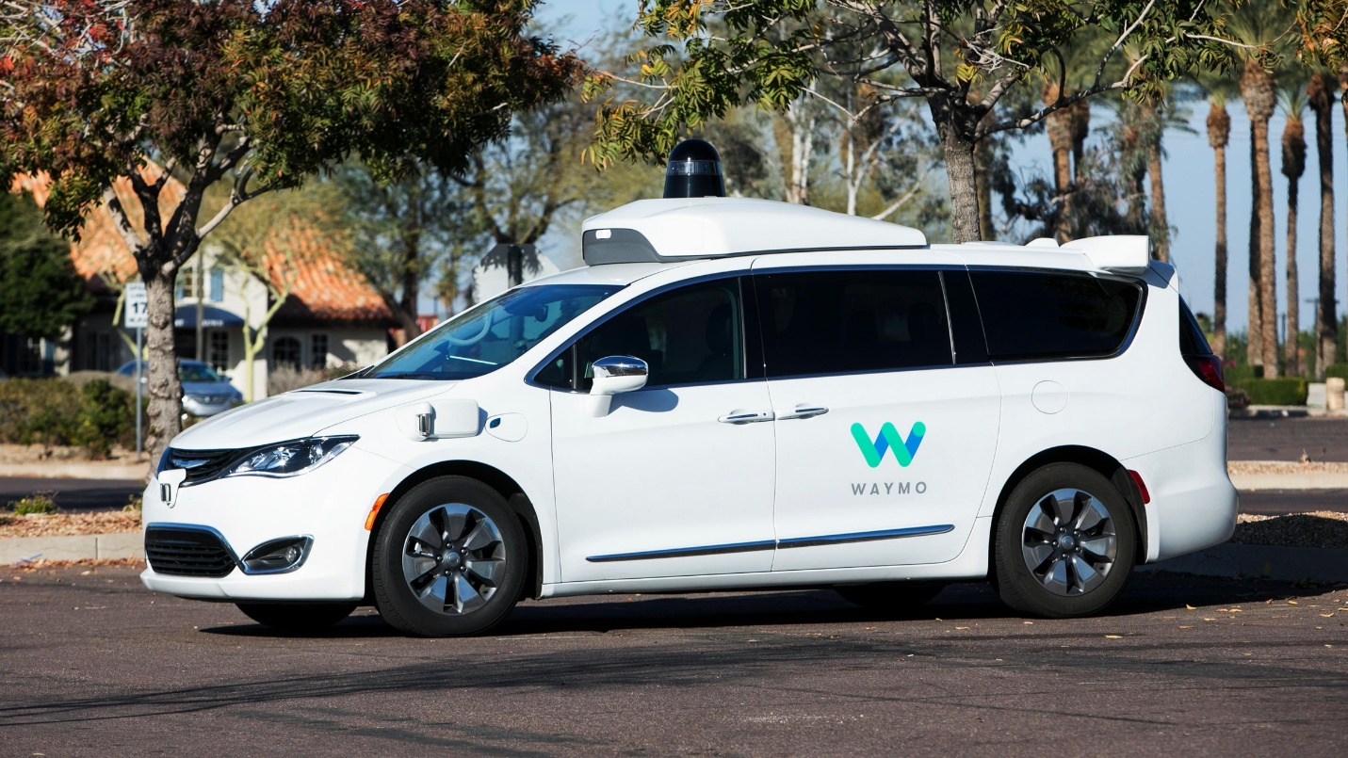

Figure 3 Waymo (Chrysler Pacifica model)

Autonomous driving functions include:

* Active parking assist.
* Lane Keep Assist.
* Blind Spot Detection.
* Electronic Stability Control.
* Adaptive Cruise Control.
* Cross-traffic alert system.
* Object recognition
* Waypoint navigation

SAE level: Level 4

Reason: Waymo has entered into a collaboration with Chrysler to make the Pacifica model autonomous capable with Level 4 autonomy. The vehicle can drive itself without too many human interactions (besides starting and entering the destination) but will be restricted to known use cases as well. Although the Waymo cars are considered fully autonomous, under critical circumstances, the human driver needs to request control and take over the vehicle.

* **Tesla model S - Autopilot:** [4]

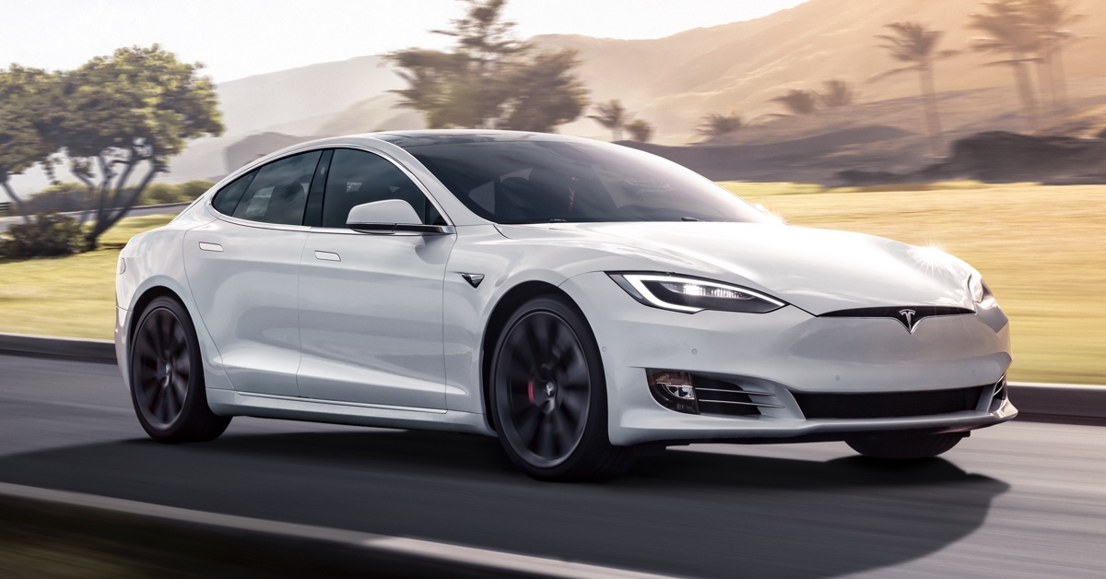

Figure 4 Tesla Model S

Autonomous driving functions include:

* Autopilot navigation includes automated driving from interstate on-ramp to off-ramp, including overtaking slower cars and interchanges.
* Automatic Park Assist: The vehicle can automatically find a sport and park in perpendicular and parallel spaces.
* Automatic lane change: The vehicle can automatically change lanes during driving on interstate roads.
* Summon: The vehicle can find the driver anywhere in the vicinity with this feature.
* Telemetry: The vehicle can differentiate traffic signs, pedestrians, and lanes through cameras.
* Safety warning alert: Autopilot feature can detect collision and alerts with a sound warning.

SAE level: Level 3

Reason: The vehicle can drive from a starting point to reach the destination without human involvement, but only in certain driving conditions. If the system is unable to drive safely or reliably, then human involvement is necessary. This typically means that the driver needs to be cautious and be ready in all circumstances.

**Question 2:**

Advantages of autonomous vehicles [5] include:

* **Reduced travel time and transportation cost:**

Autonomous cars can reduce passengers' travel time by taking control of the vehicle, reducing the hours lost in commuting. These vehicles could free up to 50 minutes per day for drivers/users who could now use the freed time for other productive activities. These cars can also reduce fuel consumption by up to 40% and reduce the workforce's cost (drivers), thereby saving the transportation cost incurred during driving.

* **Increased lane capacity:**

The introduction of autonomous vehicles commercially will create a structured driving behavior on highways and automatically increase the highway vehicle transit capacity. This will also increase the highway travel speeds by a significant percentage with safer and reliable driving involved.

* **Reduced accidents and insurance cost:**

Autonomous vehicles are an excellent solution for reduced accidents due to driver distraction and fatigue while driving by an amount of 90%. Moreover, these cars help in potentially reducing car crashes by anticipating future events based on localization algorithms. This would also save the cost incurred due to roadway accidents like insurance, repairs, damages, etc. Also, the reduced accidents on the roads due to well-structured driving behavior will reduce the insurance cost to make up for the accidents.

* **Increased Transport accessibility:**

Autonomous vehicles help in better transport accessibility for disabled people and older people. These vehicles could provide many people a solution to take care of their mobility services. With these vehicles, tasks including commuting to work, visiting family across town, going to the doctor could become easier for seniors and those with disabilities.

* **Reduced traffic congestion and CO2 emissions:**

Autonomous vehicles can reduce the stop-and-go behavior, which is frequently caused by human driving behavior since humans unnecessarily stop-and-go even in the absence of bottlenecks and lane change. These cars will reduce unnecessary traffic congestion, thereby reducing CO2 emissions.

**Question 3:**

Sensors used in autonomous vehicles [6] include:

1. Cameras
2. Radars
3. Lidars
4. Global Positioning System (GPS) sensor

* **Cameras:**

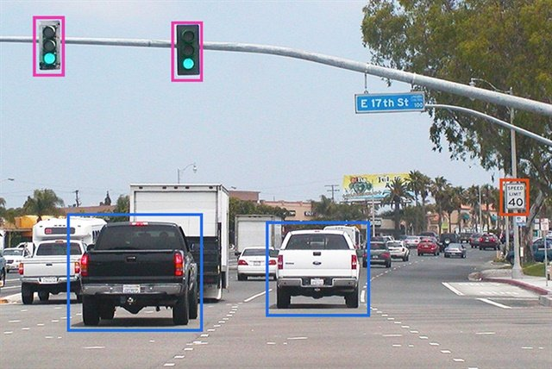

Figure 5 Object Recognition with Cameras

Cameras can be applied to autonomous driving functions, including:

* Autonomous Lane Keep Assist.
* Autonomous Parking Assist.
* Blind Spot Detection.
* Environment recognition for intelligent braking during sudden impacts.
* V2X communication (communication of current coordinate of the vehicle based on localization).
* **Radars:**

Radars can be applied to autonomous driving functions, including:

* Adaptive Cruise Control.
* Blind Spot Detection.
* Automatic Parking Assist.
* Object detection (based on relative distance and velocity between vehicles).
* V2X communication (communication of relative distance between vehicles).
* **Lidars:**

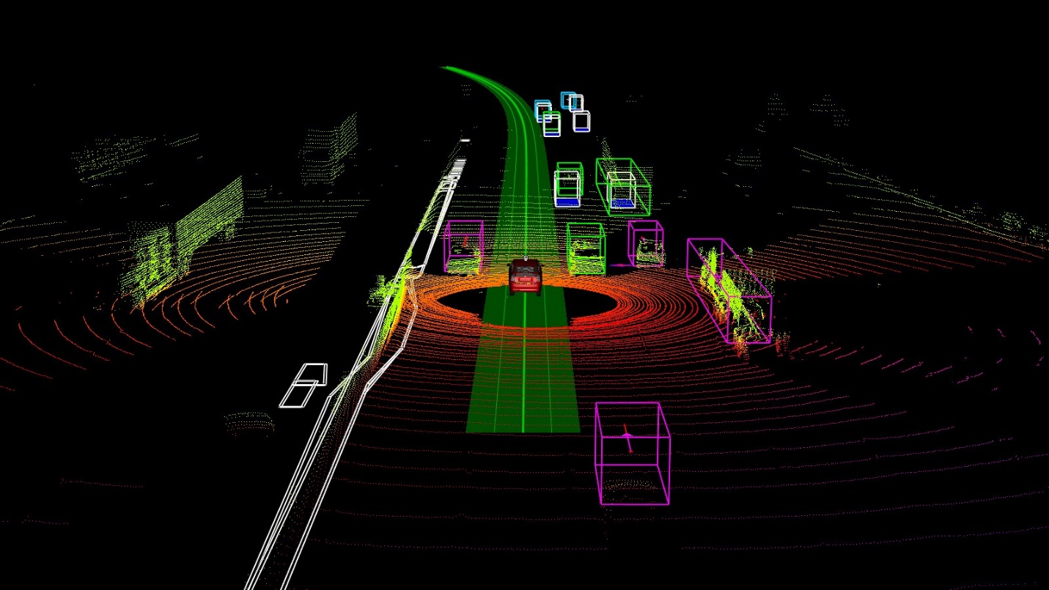

Figure 6 Lidar Object detection and tracking

Lidars can be applied to autonomous driving functions, including:

* Autonomous Lane Keep Assist (Lane detection with Pointcloud).
* Blind Spot Detection.
* Autonomous Lane Switching.
* Waypoint Navigation (using Lidar map – point cloud data)
* Environment recognition for intelligent vehicle control (Map for behavior planning and waypoint navigation controller).
* V2X communication (communication of current vehicle coordinate based on Lidar frame of reference).
* **Global Positioning System (GPS) sensor:**

GPS sensors can be applied to autonomous driving functions, including:

* Autonomous waypoint navigation.
* Autonomous Lane Switching (based on waypoints).
* Autonomous Lane Keep Assist.
* V2X communication (communication of current coordinate of the vehicle and relative velocity).

**Question 4:** [7]

Distance sensors are categorized into three types, and they are:

* Ultrasonic sensors.
* Radar (Radio Detection and Ranging) sensor.
* Lidar (Light Detection and Ranging) sensor.

The above mentioned three distance sensors have a similar principle, which is a speed-distance relationship. The distance value is determined based on the time delay of signals which are emitted and reflected. The distance sensors' variation is based on the type of wave used for propagation during emission and reception. Generally, distance is calculated using the formula,

Since the wave propagation from the emitter and back to the receiver is two way, we are multiplying by a factor of 0.5.

* **Ultrasonic sensors:**

Principle:

Ultrasonic sensors work by emitting ultrasonic sound signals towards the target. Depending upon the time delay incurred for the reflected waves to return and the sound waves' speed, the distance is determined between the vehicle and the target. The ultrasonic sensors have a transmitter to transmit sound waves and a receiver to receive the sound waves.

Advantages:

* It has the sensing capability to sense almost most of the material types.
* It can work in adverse conditions.
* It is not affected due to atmospheric dust, snow, and rain.
* It provides good readings in sensing large-sized objects with hard surfaces.

Disadvantages:

* It is very sensitive to variation in the surrounding temperature.
* It has more difficulties in reading reflections from soft, curved, thin, and small objects.
* It is limited to a short range of operation.
* Its resolution is relatively low.
* **Radar sensors:**

Principle:

Radar sensors are almost similar in functioning as the ultrasonic sensors. These sensors transmit radio waves rather than ultrasonic sound waves. These sensors work by emitting radio waves towards the target. Depending upon the time delay incurred for the reflected waves to return and the radio waves' speed, the distance is determined between the vehicle and the target.

Advantages:

* It has outstanding penetration capability and works with any weather condition, and can be used during both day and nighttime.
* It is robust against noises.

Disadvantages:

* It has low resolution.
* It works less accurately with closer targets.
* **Lidar sensors:**

Principle:

Lidar sensor works by transmitting a laser light pulse to find the distance between the sensor and the target. The distance between the sensor and the target is determined based on the time taken for each pulse to return. Lidars work by scanning the environment for 360 degrees (horizontally) and map the objects around the sensor.

Advantages:

* It has a medium range of operation with very high resolution.
* Since light travels at constant speeds, these sensors can determine the location of objects with relatively high precision.

Disadvantages:

* It is very costly.
* Less accurate due to noises in the surrounding environment, including rain, smoke, dense fog.

**Problem 2:** [8]

**Question 1:**

* Radar distance detection:



Figure 7 Sensor List with Front radars



Figure 8 Radar-based detection detection

Radar detects an object's distance based on the time travel of radio waves between the source (sensor) and object. These sensors emit radio waves towards the target, and the waves reflect the receiver. Depending upon the time taken for the waves to reflect, the distance of the target is determined. The distance is calculated by using the formula,

* Radar speed detection:

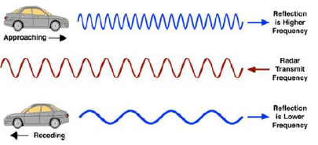

Figure 9 Radar-based speed detection

Radar detects the speed of a moving object using the Doppler effect. According to the doppler effect, there is a relative change in frequency between the emitted and receiving waves if the object is moving. The receiving frequency is smaller if the object moves away from the source at a speed v1 and larger if the object is moving towards the source at a speed v1. This can be illustrated in a formula, wherein the relation between the speed of the object and radio wave has been established,

Where

c is the speed of light.

v0 is the velocity of the source.

v1 is the velocity of the object.

f0 is the frequency of the emitted wave.

f1 is the frequency of the reflected wave.





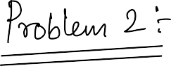

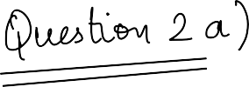

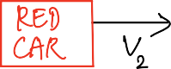 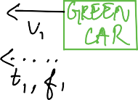

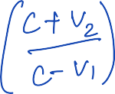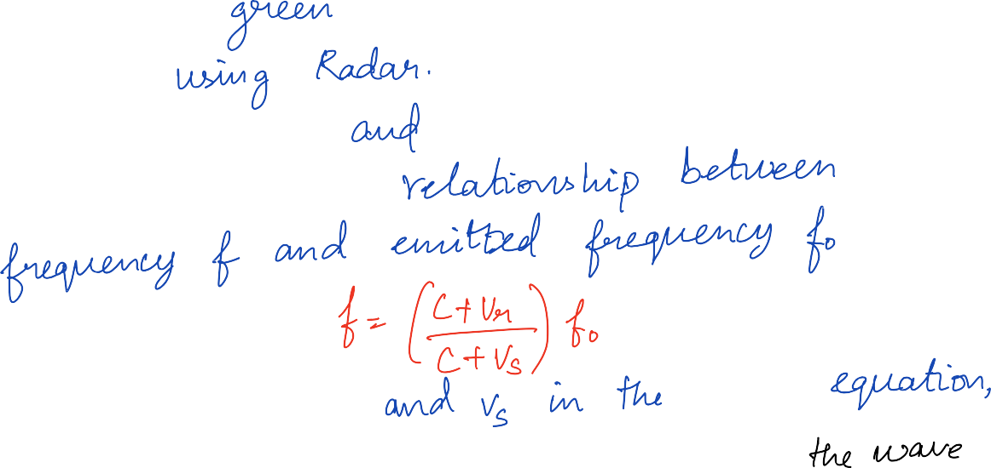

    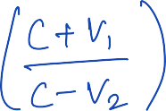 



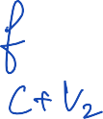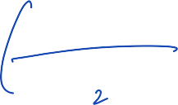

 





     





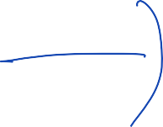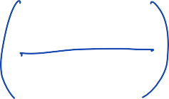

 

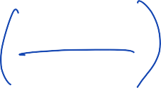





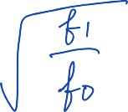

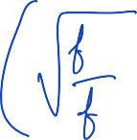

       

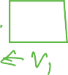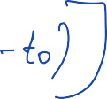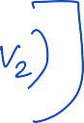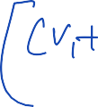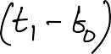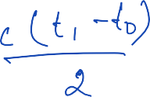

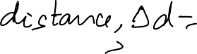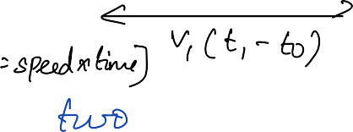

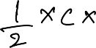



   

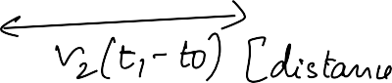

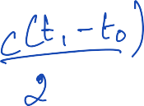

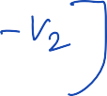

     

     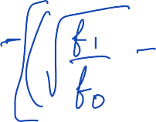    



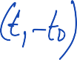

 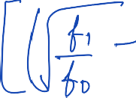 





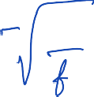

**Problem 3:**

The position of four satellites are given in the table below in the unit of Mm (megameter).

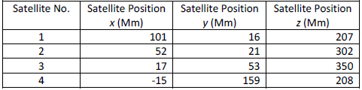

The GPS location was solved using fmincon, a nonlinear programming algorithm in MATLAB, and the initial values for X, Y, Z coordinates were equal to the radius of earth and 0 for the time difference in the clock.



Figure 10 Global Positioning System (GPS)

Equations:

The satellites, each of them, sends four values to the GPS unit, it's xi, yi, zi coordinates and the time at which it sends the signal to the GPS unit tic and time recorded at GPS will be tiv.

Hence the GPS coordinates are (x, y, z, tiv), and Satellite system coordinates are (xi, yi, zi, tic).

Distance will be,

Here b is the clock bias between GPS and satellite.

Distance between the GPS unit and one satellite is,



The difference in distance between them should be zero,



Solving for the above equation,

Hence, we must find the minimum value of the below-cost function to find the coordinates of the GPS,

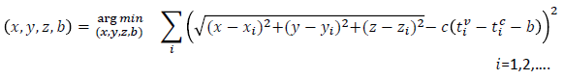

The fmincon function uses the interior point algorithm to find the most optimum solution in the least time possible. The function helped in minimizing the fun subject in the code which is the cost function based on non-linear constraints.

We are given the sending time and receiving time from at the Satellite along with the speed of radiowave which is 300 Mm/s and also the earth radius which is 6.378 Mm.

**Output:**

The coordinates of the GPS unit are as follows:

* X coordinate of GPS unit – 5.185537 Mm
* Y coordinate of GPS unit – 7.578706
* Z coordinate of GPS unit – 8.456620
* Clock Difference between GPS and satellite – 0.299846 seconds

**MATLAB script: (reference fmincon function MATHWORKS)**

%%% Author - Adithya Suresh %%%

%%% Professor - Dr. Yunyi Jia %%%

%%% Homework 1 - 3rd problem solution %%%

clear all

clc

%% Loading time data

load('st');

load('rt');

%% Data from question

x = [101,52,17,-15];

y = [16,21,53,159];

z = [207,302,350,208];

radiowave_speed = 300;

earth_radius = 6.378;

%% Time taken for individual satellite to receive the signal

time_diff = rt - st;

%% Function to calculate position of GPS unit

fun = @(a)((sqrt(((a(1)-x(1)).^(2))+((a(2)-y(1)).^(2))+((a(3)-z(1)).^(2)))-(radiowave_speed.*(time_diff(1)-a(4)))).^(2))...

+((sqrt(((a(1)-x(2)).^(2))+((a(2)-y(2)).^(2))+((a(3)-z(2)).^(2)))-(radiowave_speed.*(time_diff(2)-a(4)))).^(2))...

+((sqrt(((a(1)-x(3)).^(2))+((a(2)-y(3)).^(2))+((a(3)-z(3)).^(2)))-(radiowave_speed.*(time_diff(3)-a(4)))).^(2))...

+((sqrt(((a(1)-x(4)).^(2))+((a(2)-y(4)).^(2))+((a(3)-z(4)).^(2)))-(radiowave_speed.*(time_diff(4)-a(4)))).^(2));

initial_data = [earth_radius,earth_radius,earth_radius,0];

A = [];

B = [];

C = [];

D = [];

E = [];

F = [];

func_variable = @equation;

GPS_position = fmincon(fun, initial_data, A, B, C, D, E, F, func_variable);

Local minimum possible. Constraints satisfied.

fmincon stopped because the size of the current step is less than

the value of the step size tolerance and constraints are

satisfied to within the value of the constraint tolerance.

<stopping criteria details>

%% Output

fprintf('X coordinate position of the GPS is %f Mm \n',GPS_position(1));

X coordinate position of the GPS is 5.185537 Mm

fprintf('Y coordinate position of the GPS is %f Mm \n',GPS_position(2));

Y coordinate position of the GPS is 7.578706 Mm

fprintf('Z coordinate position of the GPS is %f Mm \n',GPS_position(3));

Z coordinate position of the GPS is 8.456620 Mm

fprintf('Clock difference between GPS unit clock and Satelite system clock is %f s \n',GPS_position(4));

Clock difference between GPS unit clock and Satelite system clock is 0.299846 s

Equation function:

function [c,ceq] = equation(m)

c = [5-m(1) m(1)-20 5-m(2) m(2)-20 5-m(3) m(3)-20 -10-m(4) m(4)-10];

ceq=[];

# References

|  |  |
| --- | --- |
| [1] | "Tesla Model S," [Online]. Available: https://www.tesla.com/models. |
| [2] | "Waymo," [Online]. Available: https://waymo.com/tech/. |
| [3] | "Audi A8," [Online]. Available: https://www.audiusa.com/us/web/en/models/a8/a8-sedan/2021/overview.html. |
| [4] | "Cadillac CT6," [Online]. Available: https://www.cadillac.com/world-of-cadillac/innovation/super-cruise. |
| [5] | "Advantages of Autonomous driving," [Online]. Available: https://www.itsdigest.com/10-advantages-autonomous-vehicles. |
| [6] | "Perceptive Sensors," [Online]. Available: https://www.techbriefs.com/component/content/article/tb/stories/blog/37699. |
| [7] | "RADAR detection Dr. Jia slides," [Online]. Available: https://clemson.instructure.com/courses/128604/files/folder/Lecture%20Slides?preview=9023350. |
| [8] | "Pros and Cons - Radar and Lidar," [Online]. Available: https://archer-soft.com/blog/lidar-vs-radar-pros-and-cons-autonomous-driving. |